When the customer first clicks the link on your website they will be redirected to the ecommerce website. Initially they will select Register:
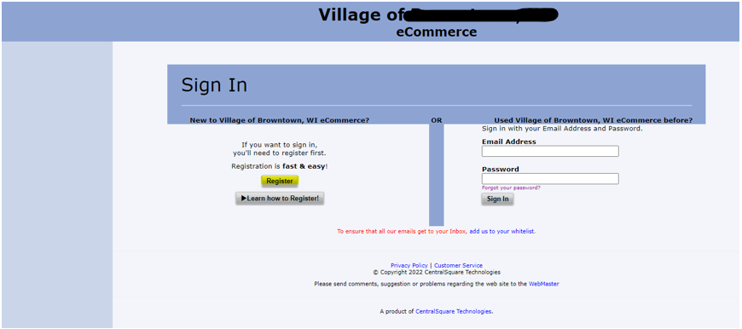
They will fill in the below information and select continue:
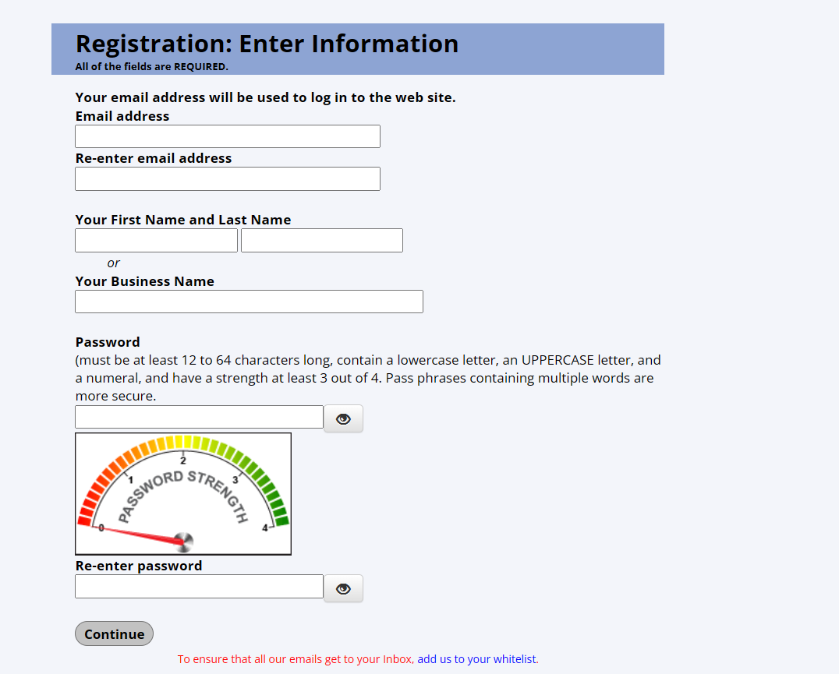
After entering in the required information, they will be taken to the following confirmation message page:
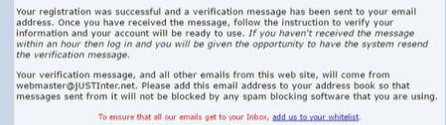
After completing the registration, they will receive an automatic email notification at the email address they provided during registration with an activation link to verify their new account:
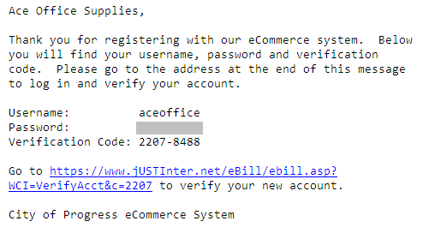
After clicking on the link they will be taken to the following verification page:
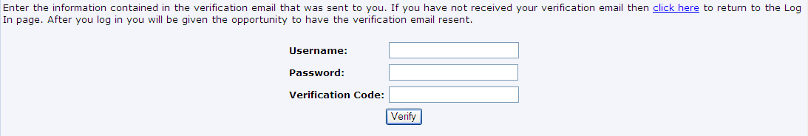
After typing in their username, password, and the verification code they received in the email they will be taken to their main account page:
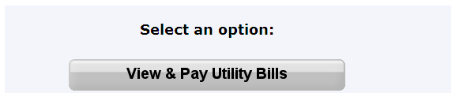
From here, they simply need to click  to continue to their Utility Billing account profile.
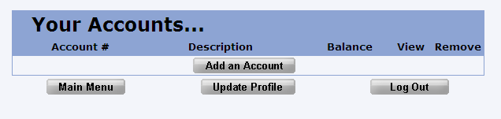

By default, their account list will be empty, so click to add a new account:

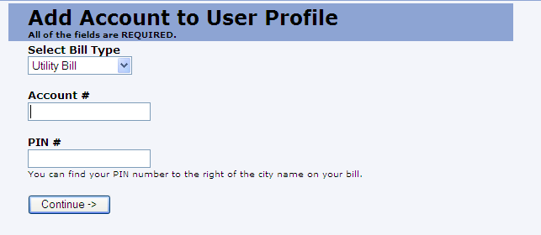
Enter in the account number and the associated PIN number from their account to attach it to the ebilling system. They can retrieve their PIN number and Account number from their paper bills.
After clicking continue they will be taken to the following EULA:
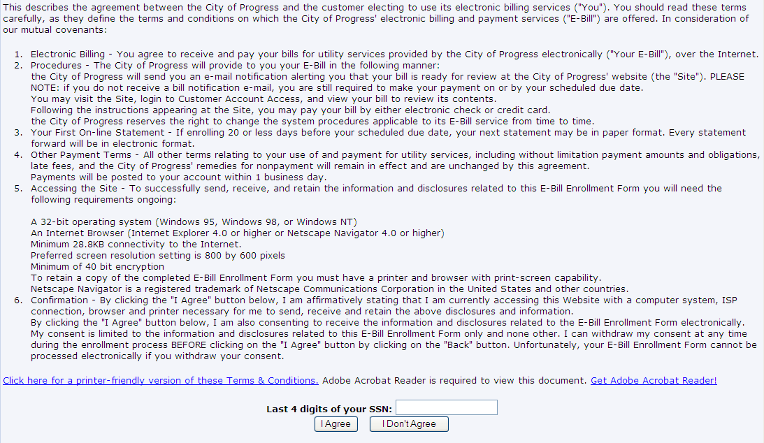
After entering in their last 4 digits of their SSN and indicating that they agree to the EULA terms they will be taken back to their profile with a message indicating that they will receive an email once their registration request has been processed in asyst.
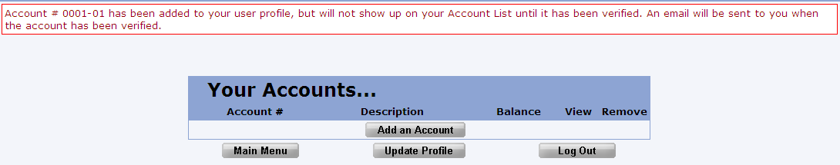
Once the city confirms the registration the customer will receive an automated email indicating that their registration was processed:
:
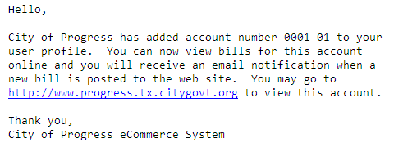
At which point they can go back to their profile and view their bill if any has been uploaded:
